DATE: 29/03/2024

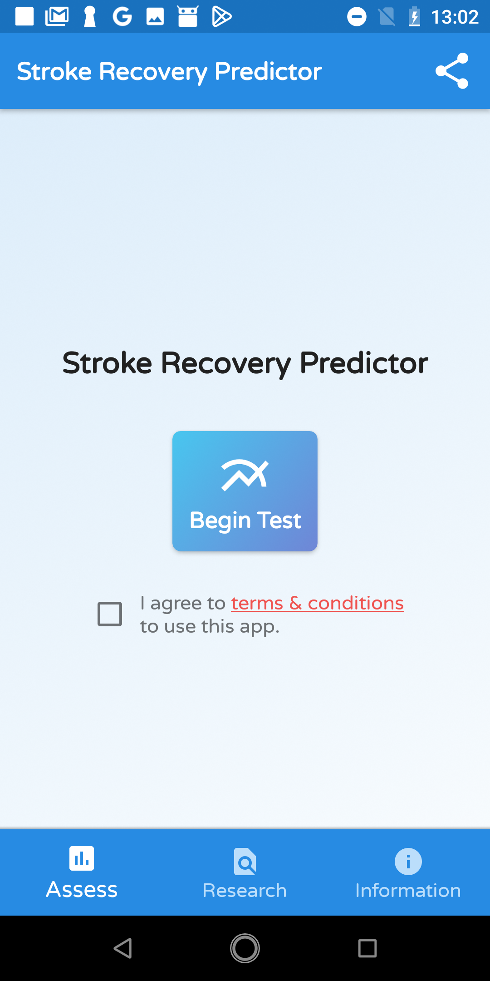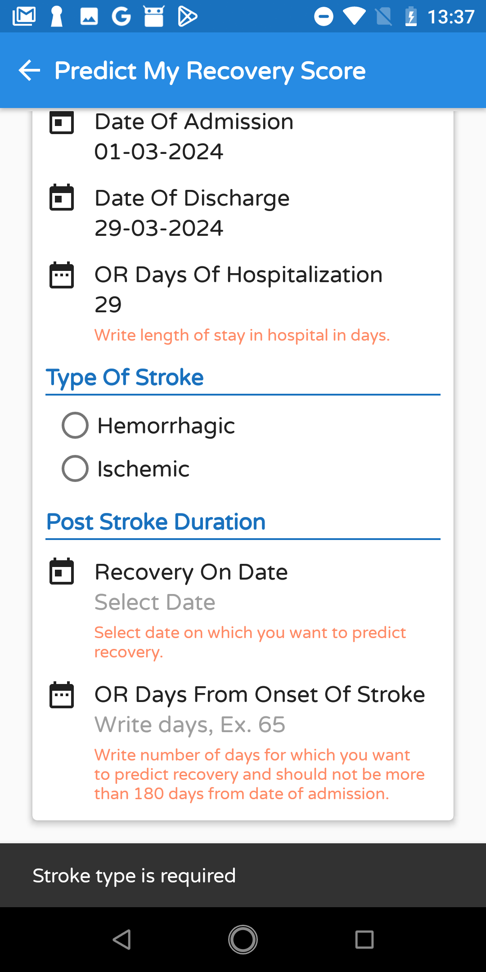

TASK: Assess recovery of stroke

To the right, we can see four screenshots that were captured while assessing predicted recovery.

1. We can see that some text is small and has a low contrast between text and background. This would violate heuristic number one, **visibility of system status.**

2. In the second screenshot, we can see that an error message is prompted; moreover, the error message text is small, and the error message itself is prompted for a very short time, which increases the difficulty of reading the message before it is gone, this would violate the ninth heuristic, **help users recognise, diagnose, and recover from errors**.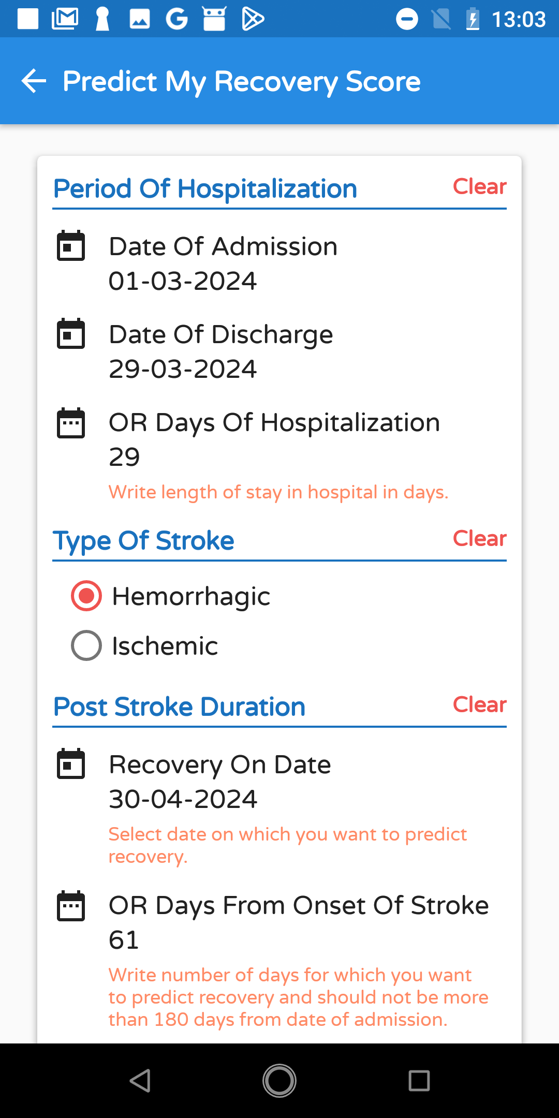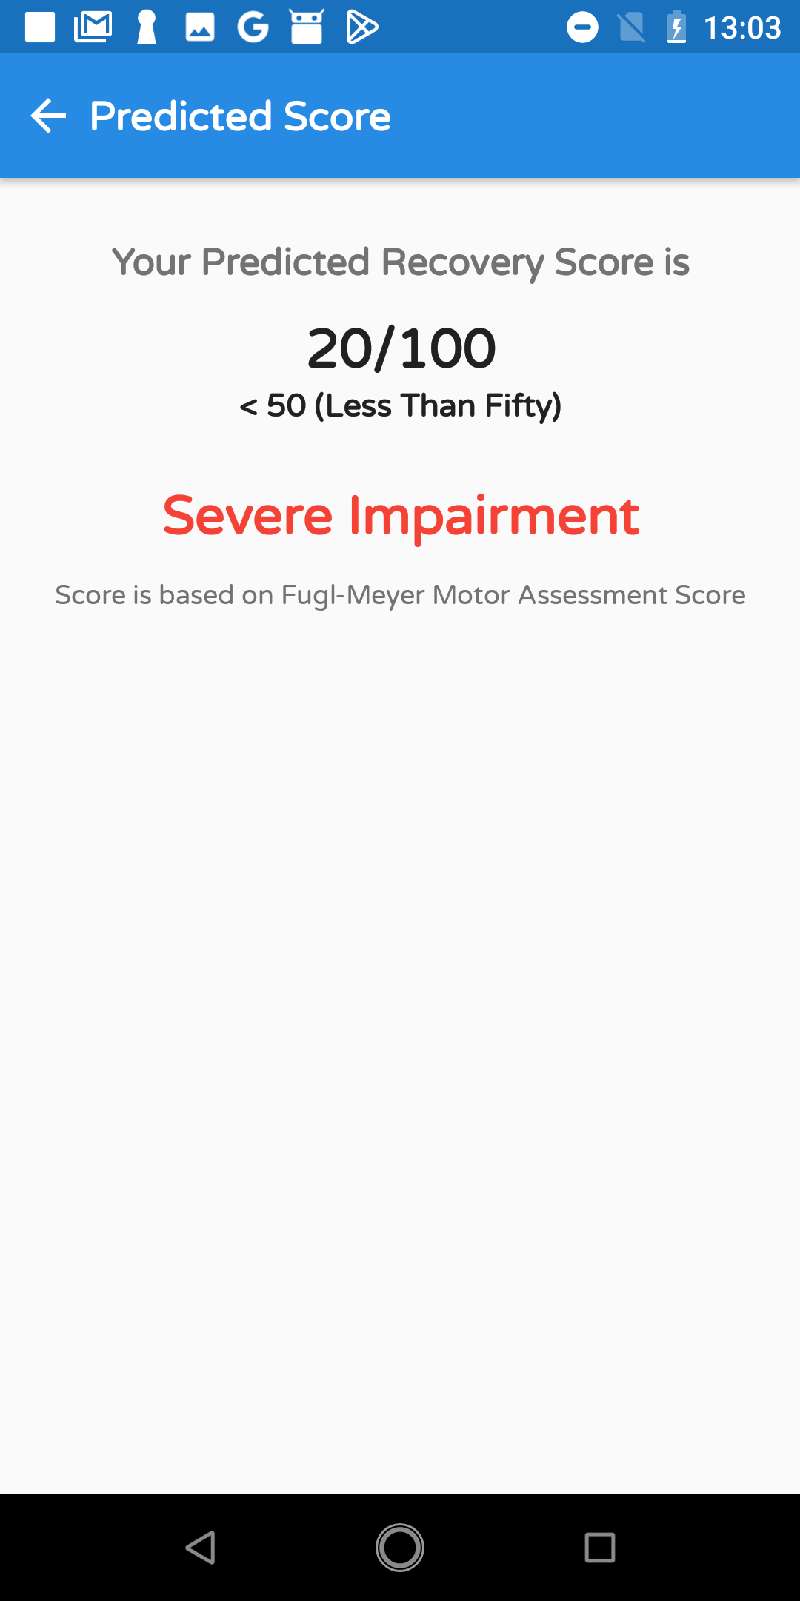

3. On the first screen, users are always prompted to click “I agree to terms & conditions…” every time they run a new test (i.e., “Begin Test” button). This could be asked only once so it does not violate the heuristic of “Flexibility and Efficiency of Use.”

FURTHER REMARKS:

While swapping between the different sections of the app, it was found that if the user does this at a rather quick pace, the app crashes.